Algorithm Modelling Tools : Flowchart , Pseudo-code, Trace Table

 | Structured English | Pseudocode | Flowchart
Sequence and Assignment | SET A TO 100  INCREMENT A BY 1 | DECLARE A: INTEGER  A <- A + 1
Input | GET INPUT B FOR TEMPERATURE IN CELCIUS | OUTPUT "Enter Temp. in Cels"  INPUT B
Output | OUTPUT "TEMPERATURE IN CELSIUS IS ", B | OUTPUT "Temp in Cels =", B
Selection | IF A IS GREATER THAN B THEN  SET C TO FUNCTION Factorial(A)  ELSE IF  SET C TO FUNCTION SqRoot(B)  ELSE  SET C TO FUNCTION SqRoot(A) | DECLARE A, B : INTEGER  INPUT A, B  IF A > B THEN  C <- factorial(A)  ELSE IF A = B THEN  C <- SqRoot(B)  ELSE  C <- SqRoot(A)  ENDIF
Iteration | WHILE A IS GREATER THAN B INCREMENT B by 1 | WHILE A > B  B <- B + 1  ENDWHILE
Iteration | FOR I = 1 TO 10 OUTPUT I*I | // I is assigned from 1 to 10 inclusive  // increment can be negative  FOR I <- 1 TO 10 STEP 1  OUTPUT I*I  NEXT I
FLOWCHART RULES:
- Except for the DECISION SYMBOL, Only 1 arrow in and 1 arrow out
- DECISION SYMBOL has 1 arrow in and 2 arrows out (Y and N)
- LINES cannot cross each other
- START terminator may be a FUNCTION declaration
- END terminator may be a RETURN
- SYNTAX follows Pseudo code conventions
SYMBOLS
TERMINATOR (START, END, FunctionName, RETURN)
PROCESS (DECLARE, ASSIGN, Calculate)
INPUT,OUTPUT
DECISION

Pseudo-code Notes:
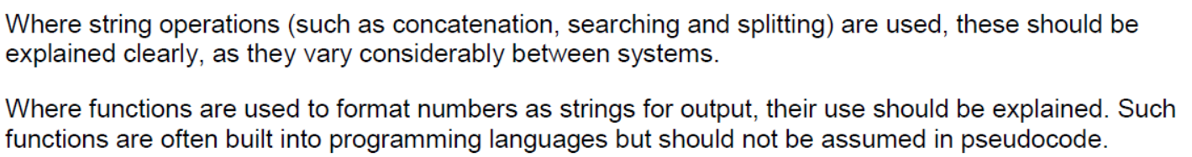
Declaring variables | DECLARE MyScore : INTEGER
Declaring a 1-D array | DECLARE Marks: ARRAY[0:9] OF INTEGER  DECLARE Names: ARRAY[0:9] OF STRING
Declaring a 2-D array | DECLARE Marks: ARRAY[0:9] OF (ARRAY[0:3] OF STRING)
Using an Abstract Data Type like List, Dictionary | DECLARE Marks : LIST  DECLARE Scores : DICTIONARY  Marks.APPEND(10) // Describe APPEND method  Marks.SUBLIST(2,4) // Describe SUBLIST to implement slicing operator in Python List  Scores["John"] = 58 // Store a dictionary object with a key "John"
Declaring a function/method | FUNCTION Factorial(n : INTEGER) RETURNS INTEGER  DECLARE Result : INTEGER  Result ← 1  FOR i ← 1 TO n  Result ← Result * i  ENDFOR  RETURN Result  ENDFUNCTION

Practice:

- Create a flowchart to model the following Python code:

a = 1
while a % 7 != 0:
if a % 2 == 0:
print("O" , end = "")
if a == 2:
print("X" , end = "")
a = a + 1
print("")

- Write pseudo code for the following Python code:

divisor = 2
for i in range(0, 10, 2):
print(i // divisor)

- You are tasked to find the smallest and second smallest integers in an array of integers in a single pass. You are not allowed to sort the array. You can assume that the array has already been initialised with a list of distinct integers.
Express your algorithm using pseudocode.

- 2023/A Level/P1/Q6(c)(ii)
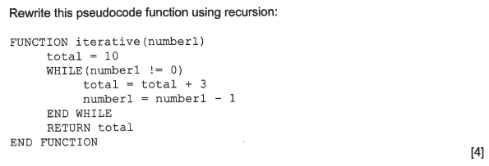

Exercise 13.4 2019/A Level/P1/Q5 H2 Computing (Modified)

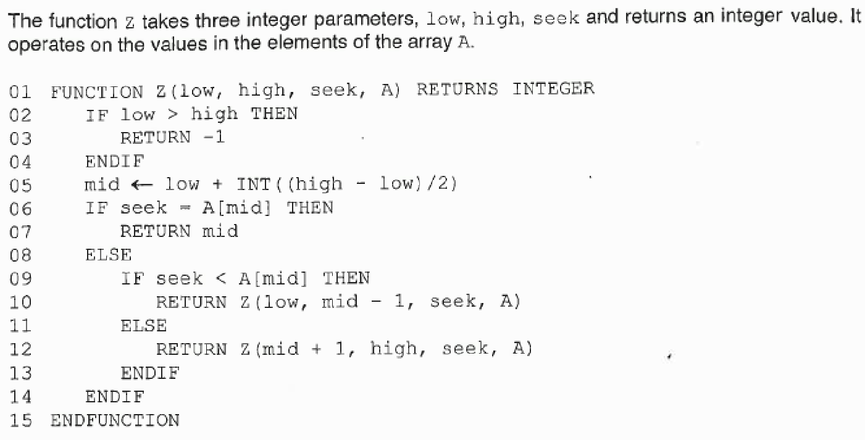

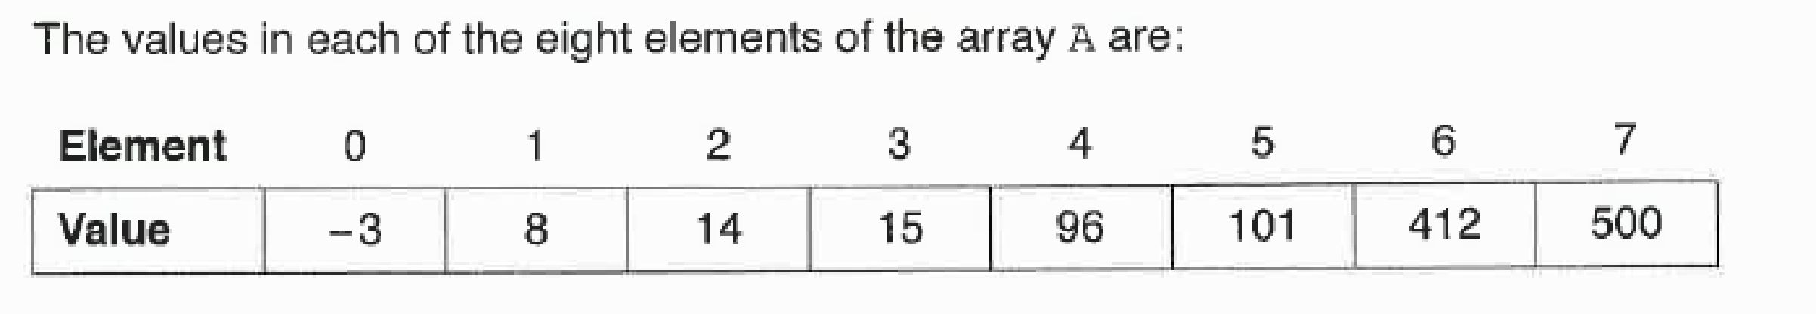

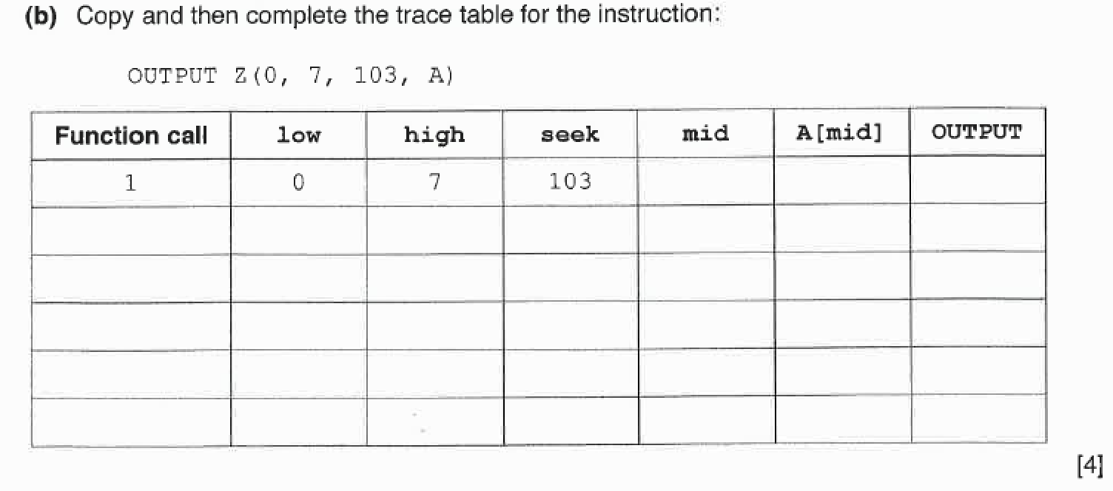
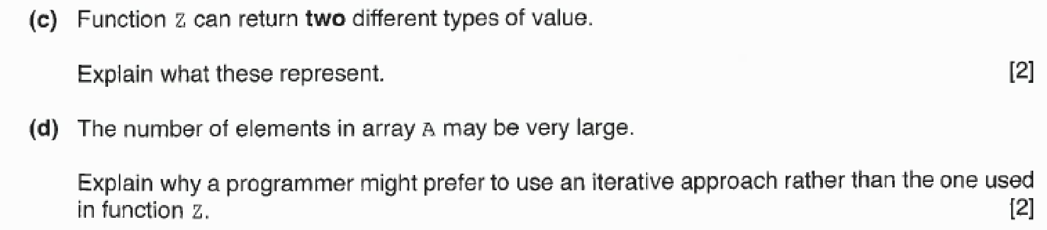

Algorithm Modelling - References

- General Algorithm Design
- Github Notes Chapter 08., Exercise 13
- Cambridge International AS and A Level - Computer Science (9806)
  - Chapter 11

- AQA Computing – AS Computing
  - Unit 1.4

- BBC Bitesize Revision
  - https://www.bbc.com/bitesize/guides/z3bq7ty/revision/1

1. Pseudocode
- Cambridge Pseudocode Guide
  - https://drive.google.com/file/d/1vBm4iswJF66zYW-4oNj1NkRwC1DHbZ3o/view?usp=sharing

2. Flow Charts
- Creately Tutorial on Drawing Flow Charts
  - https://creately.com/blog/diagrams/flowchart-guide-flowchart-tutorial/

- Online Flow Chart Drawing Tool
  - https://www.draw.io/

